Requirements Engineering

Contents
Actors 1
Business Requirements (BR) 2
Functional Requirements (FR) 3
Customer Web Application 3
Mobile Application (Android / iOS) 5
Agency Desktop Application 6
Administration Functions 7
Backend Services 8
Non-Functional Requirements (NFRs) 10
Requirements Diagrams 11
Package 1: Business Requirements 11
Package 2: Functional Requirements 12
Package 3: Non-Functional Requirements 17

Figures
Figure 1 - Top Level Requirement Diagram (Business View) 11
Figure 2 - Customer Requirements Diagram 12
Figure 3 - Mobile Application Requirements Diagram 13
Figure 4 - Agency Management Requirements Diagram 14
Figure 5 - Administration Requirements Diagram 15
Figure 6 - Backend Services Requirements Diagram 16
Figure 7 - Performance Non-Functional Requirements Diagram 17
Figure 8 - Security Non-Functional Requirements Diagram 18
Figure 9 - Reliability Non-Functional Requirements Diagram 19
Figure 10 - Availability Non-Functional Requirements Diagram 20
Figure 11 - Scalability Non-Functional Requirements Diagram 21
Figure 12 - Accessibility Non-Functional Requirements Diagram 22
Figure 13 - Maintainability & Compatibility Non-Functional Requirements Diagram 23
Figure 14 - Usability Non-Functional Requirements Diagram 24

Actors
Tourist / Customer
Customers are the key to the project’s success. By focusing on carefully identifying their needs, they can browse, search, and compare different offers and, of course, they can use the smart assistant to make this process easier. The platform also allows them to make online payments and gives them the full right to share their opinions and ratings.
Key actions:
- Search cars, compare offers, book vehicles, pay online, rate agencies.
Rental Agency
Rental agencies are the primary source of inventory and therefore also play a key role in success; Their requirements must be taken into account and fulfilled to the best of our ability. The platform allows agencies to register their companies and various branches nationwide. They can manage their inventory and approve or reject rental requests, and the platform also enables them to track their data with precise details in real time.
Key actions:
- Register company, manage vehicles, approve reservations, track rentals.
Administrator
Platform managers have a role that allows them to monitor platform statistics—including users, agencies, payments, and more. They are responsible for reviewing and approving or rejecting agency applications and finalizing agreements, all of which, of course, is done upon instructions from the highest authority (the CEO).
Key actions:
- Verify agencies, monitor platform, manage disputes, manage payments.

Business Requirements (BR)
BR-01 National Rental Agency Marketplace
KriGo shall provide a centralized platform that aggregates rental agencies across Algeria and presents their vehicle offers to customers.

BR-02 Increased Agency Visibility
The platform shall help rental agencies increase their online visibility and customer reach without requiring their own software systems.

BR-03 Simplified Vehicle Discovery
The platform shall enable customers and tourists to quickly find suitable rental vehicles based on location, availability, and preferences.

BR-04 AI-Assisted Decision Support
The platform shall provide intelligent recommendations to help customers choose the most appropriate rental vehicle.

BR-05 Tourism Support
The platform shall facilitate vehicle rentals for domestic and international tourists by providing multilingual access and location-based services.

BR-06 Digital Transformation of Agencies
The platform shall provide agencies with digital tools for managing vehicles, reservations, and customer requests.

BR-07 Marketplace Neutrality
The platform shall operate solely as an intermediary and shall not participate in or modify rental agreements between agencies and customers.

BR-08 Multi-Platform Accessibility
The platform shall be accessible through web, mobile, and desktop applications.

BR-09 Low Technical Barrier
The platform shall remain usable on standard devices and average internet connections commonly available in Algeria.

BR-10 Revenue Generation
The platform shall support subscription plans, commissions, or promotional services for participating agencies.

Functional Requirements (FR)
The Functional Requirements have been divided into five key sections to facilitate the debugging process later on and to make them easier to locate. The first two sections are “Customer Web Application” and “Mobile Application (Android/iOS),” which cover customer requirements; the third section is “Agency Desktop Application,” which addresses agency requirements; and finally, “Administration Functions” and “Backend Services” focus on system requirements in general.

Customer Web Application
FR-01: User Registration and Authentication
The system shall provide user registration and authentication capabilities for customers. The system shall allow customers to:
- Register a new account using the required personal information.
- Log in and log out securely.
- Recover or reset forgotten passwords.
- View and update their profile information.
FR-02: Vehicle Search
The system shall enable customers to search for available vehicles using one or more of the following search criteria:
- Wilaya (province).
- City.
- Rental agency.
- Pickup location.
- Pickup date.
- Return date.
The system shall display only vehicles that match the specified search criteria and are available during the selected rental period.
FR-03: Vehicle Filtering
The system shall allow customers to refine vehicle search results using the following filtering criteria:
- Rental price.
- Vehicle category.
- Vehicle brand.
- Transmission type.
- Fuel type.
- Number of seats.
- Rental agency rating.
The system shall update the displayed results according to the selected filters.

FR-04: Vehicle Comparison
The system shall allow customers to compare multiple vehicle offers simultaneously, including their pricing, specifications, rental conditions, and rental agency information.
FR-05: Vehicle Details
The system shall provide detailed information for each available vehicle, including:
- Vehicle photographs.
- Technical specifications.
- Rental terms and conditions.
- Rental pricing information.
- Deposit requirements.
- Rental agency information.
FR-06: Artificial Intelligence Assistant
The system shall provide an AI-powered assistant capable of:
- Answering customer inquiries related to vehicle rental services.
- Recommending suitable vehicles based on customer preferences.
- Suggesting alternative rental options when the requested options are unavailable or unsuitable.
- Explaining rental terms and conditions.
- Assisting tourists and customers who are unfamiliar with local rental agencies and services.
FR-07: Reservation Management
The system shall allow customers to:
- Create reservation requests.
- Modify existing reservations.
- Cancel reservation requests.
- View and track the current status of their reservations.
FR-08: Ratings and Reviews
The system shall allow customers to submit ratings and reviews for rental agencies and rental experiences after the completion of a reservation.
FR-09: Notifications
The system shall provide customers with notifications related to their reservations, including:
- Reservation confirmation notifications.
- Reservation status updates.
- Vehicle pickup reminders.
- Vehicle return reminders.

Mobile Application (Android / iOS)
FR-10: Mobile Vehicle Search
The mobile application shall enable users to search for available vehicles using mobile devices. The search functionality shall support the same search criteria available on the web platform and display available rental options optimized for mobile viewing.
FR-11: Quick Booking
The mobile application shall allow users to create reservations through a simplified booking process optimized for mobile devices, minimizing the number of steps required to complete a reservation.
FR-12: Location Services
The mobile application shall provide location-based services, including:
- Detecting the user's current geographic location, subject to user permission.
- Displaying nearby rental agencies based on the user's location.
- Recommending the nearest available pickup locations.
FR-13: Push Notifications
The mobile application shall send real-time push notifications to users regarding reservation confirmations, reservation status updates, pickup reminders, and other relevant service notifications.
FR-14: Offline Data Caching
The mobile application shall store recently viewed vehicle listings and related information locally on the user's device to provide limited access when an internet connection is unavailable.

Agency Desktop Application
FR-15: Agency Authentication
The system shall provide secure authentication and authorization mechanisms that allow authorized agency employees to access agency management functionalities.
FR-16: Fleet Management
The system shall enable authorized agency employees to manage their vehicle inventory by allowing them to:
- Add new vehicles to the fleet.
- Edit existing vehicle information.
- Remove vehicles from the fleet.
- Upload and manage vehicle photographs.
FR-17: Availability Management
The system shall enable agencies to manage vehicle availability by allowing them to:
- Define vehicle availability schedules.
- Mark vehicles as unavailable for maintenance or other operational reasons.
- Update the current status of vehicles.
FR-18: Reservation Management
The system shall enable agencies to manage customer reservations by allowing them to:
- View reservation requests and reservation details.
- Accept reservation requests.
- Reject reservation requests.
- Mark reservations as completed upon the conclusion of the rental period.
FR-19: Pricing Management
The system shall enable agencies to configure rental pricing policies by allowing them to:
- Define vehicle pricing rules.
- Configure seasonal pricing adjustments.
- Specify deposit requirements.
FR-20: Customer Management
The system shall allow agencies to access customer reservation histories and rental records associated with their agency.
FR-21: Reporting Dashboard
The system shall provide agencies with access to reporting and analytics features, including:
- Revenue reports.
- Reservation and booking statistics.
- Fleet utilization reports.

Administration Functions
FR-22: Agency Verification
The system shall provide administrators with the ability to review, approve, or reject rental agency registration requests based on the required verification criteria and supporting documentation.
FR-23: User Management
The system shall enable administrators to manage platform users, including:
- Customer accounts.
- Rental agency accounts.
- Administrative and staff accounts.
The system shall allow administrators to view, modify, activate, suspend, or deactivate authorized accounts.
FR-24: Content Moderation
The system shall enable administrators to monitor and manage user-generated content and platform disputes, including:
- Customer reviews and ratings.
- User reports and complaints.
- Reservation and service disputes.
FR-25: System Monitoring
The system shall provide administrators with monitoring capabilities to oversee platform performance, system availability, user activity, and overall platform usage statistics.

Backend Services
FR-26: Centralized API Services
The backend system shall provide centralized application programming interfaces (APIs) to support communication and data exchange with the following client applications:
- Web application.
- Mobile application.
- Desktop application.
The APIs shall provide secure and consistent access to system functionalities and data.
FR-27: Centralized Database
The backend system shall maintain a centralized database that stores and manages all platform data, including:
- User accounts.
- Rental agencies.
- Vehicle information.
- Reservations.
- Ratings and reviews.
The centralized database shall ensure data consistency and integrity across all platform components.
FR-28: Recommendation Engine
The backend system shall provide an AI-powered recommendation engine that generates personalized vehicle recommendations based on:
- User preferences.
- User location.
- Budget constraints.
- Vehicle availability.
The recommendation engine shall support customer search and decision-making processes.
FR-29: Notification Service
The backend system shall provide a notification service responsible for managing and delivering:
- Email notifications.
- SMS / WhatsApp notifications.
- Push notifications.
The notification service shall support the delivery of reservation updates, reminders, and other system-generated messages.
FR-30: Audit Logging
The backend system shall maintain audit logs of all critical system activities, including user actions, administrative operations, reservation transactions, and system events, for monitoring, security, and traceability purposes.

(Missing requirements 31 -> 34 added after review)
FR-31: Branch Management
The system shall allow authorized rental agency administrators to manage agency branches. The system shall support creating, updating, viewing, and deleting branch information, including branch location, contact details, operating hours, and assigned resources. The system shall prevent the deletion of branches that have active reservations, employees, or ongoing rental operations associated with them.
FR-32: Employee Management
The system shall allow authorized rental agency administrators to manage employee accounts and assignments. The system shall support creating, updating, viewing, and deleting employee records, assigning employees to specific branches, and managing employee roles and permissions. The system shall validate employee information and prevent the removal of employees who are associated with active operational responsibilities.
FR-33: Financial Management
The system shall allow rental agencies to monitor and manage financial information related to their operations. The system shall provide access to transaction records, revenue summaries, payment histories, and financial reports. The system shall support exporting financial data and generating financial summaries while ensuring secure access to financial information.
FR-34: Favorites Management
The system shall allow authenticated customers to save, view, and manage favorite vehicles for future reference. The system shall support adding vehicles to a favorites list, removing saved vehicles, and displaying the customer's saved vehicles across web and mobile platforms. The system shall prevent duplicate entries and maintain the user's favorites data securely.

Functional Requirement | Corresponding Business Requirement(s)
FR-31 Branch Management | BR-06 Digital Transformation of Agencies
FR-32 Employee Management | BR-06 Digital Transformation of Agencies
FR-33 Financial Management | BR-06 Digital Transformation of Agencies, BR-10 Revenue Generation
FR-34 Favorites Management | BR-03 Simplified Vehicle Discovery, BR-04 AI-Assisted Decision Support

Non-Functional Requirements (NFRs)
Performance
NFR-01 Vehicle search results shall be displayed within 3 seconds.
NFR-02 Reservation requests shall be processed within 5 seconds.
NFR-03 The system shall support at least 5,000 concurrent users during initial deployment.
Availability
NFR-04 The platform shall maintain at least 99.5% uptime.
NFR-05 The system shall automatically recover from service failures.
Scalability
NFR-06 The architecture shall support the addition of new agencies without requiring system redesign.
NFR-07 The backend shall support horizontal scaling.
Security
NFR-08 All communications shall use HTTPS encryption.
NFR-09 Passwords shall be stored using secure hashing algorithms.
NFR-10 Role-based access control shall be implemented.
NFR-11 Sensitive customer information shall be encrypted in storage.
Usability
NFR-12 Interfaces shall be easy to learn for first-time users.
NFR-13 Core rental tasks shall require no more than five navigation steps.
NFR-14 The interface shall use clear typography and accessible color schemes.
NFR-15 The interface shall avoid intrusive advertisements and unnecessary screens.
Compatibility
NFR-16 The web application shall support modern browsers.
NFR-17 The mobile application shall support Android and iOS.
NFR-18 The agency desktop application shall support Windows.
Maintainability
NFR-19 The system shall use a modular architecture.
NFR-20 System components shall be independently deployable and maintainable.
Reliability
NFR-21 The system shall prevent double-booking of vehicles.
NFR-22 All reservations shall maintain transactional consistency.
NFR-23 The system shall preserve data integrity during failures.
Accessibility
NFR-24 The platform shall support Arabic, French, and English.
NFR-25 The platform shall remain usable on low-bandwidth internet connections.
NFR-26 The platform shall function correctly on standard consumer devices without requiring specialized hardware.

Requirements Diagrams

Package 1: Business Requirements
Diagram 1 – Business Requirements Overview
- BR-01 National Rental Agency Marketplace
- BR-02 Increased Agency Visibility
- BR-03 Simplified Vehicle Discovery
- BR-04 AI-Assisted Decision Support
- BR-05 Tourism Support
- BR-06 Digital Transformation of Agencies
- BR-07 Marketplace Neutrality
- BR-08 Multi-Platform Accessibility
- BR-09 Low Technical Barrier
- BR-10 Revenue Generation
This is the root requirement diagram.
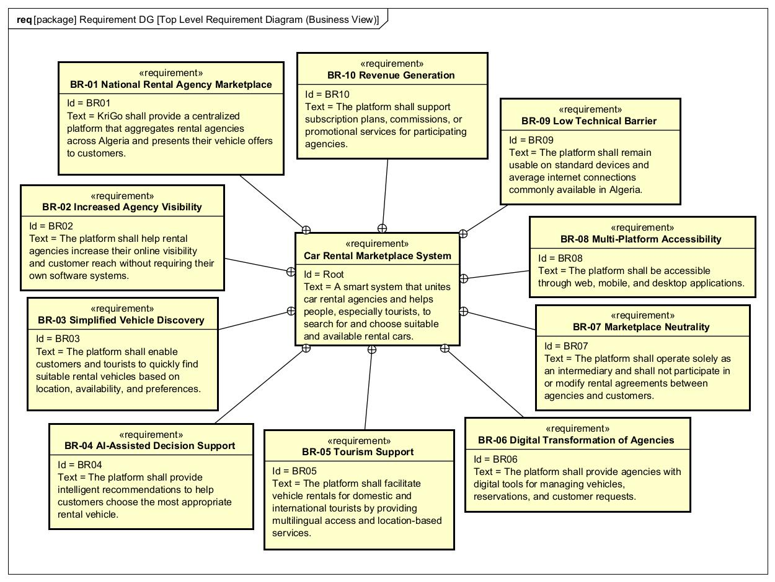
Figure 1 - Top Level Requirement Diagram (Business View)

Package 2: Functional Requirements
Diagram 2 – Customer Requirements
- FR-01 User Registration and Authentication
- FR-02 Vehicle Search
- FR-03 Vehicle Filtering
- FR-04 Vehicle Comparison
- FR-05 Vehicle Details
- FR-06 AI Assistant
- FR-07 Reservation Requests
- FR-08 Ratings and Reviews
- FR-09 Notifications
Trace to:
- BR-03 Simplified Vehicle Discovery
- BR-04 AI-Assisted Decision Support
- BR-05 Tourism Support
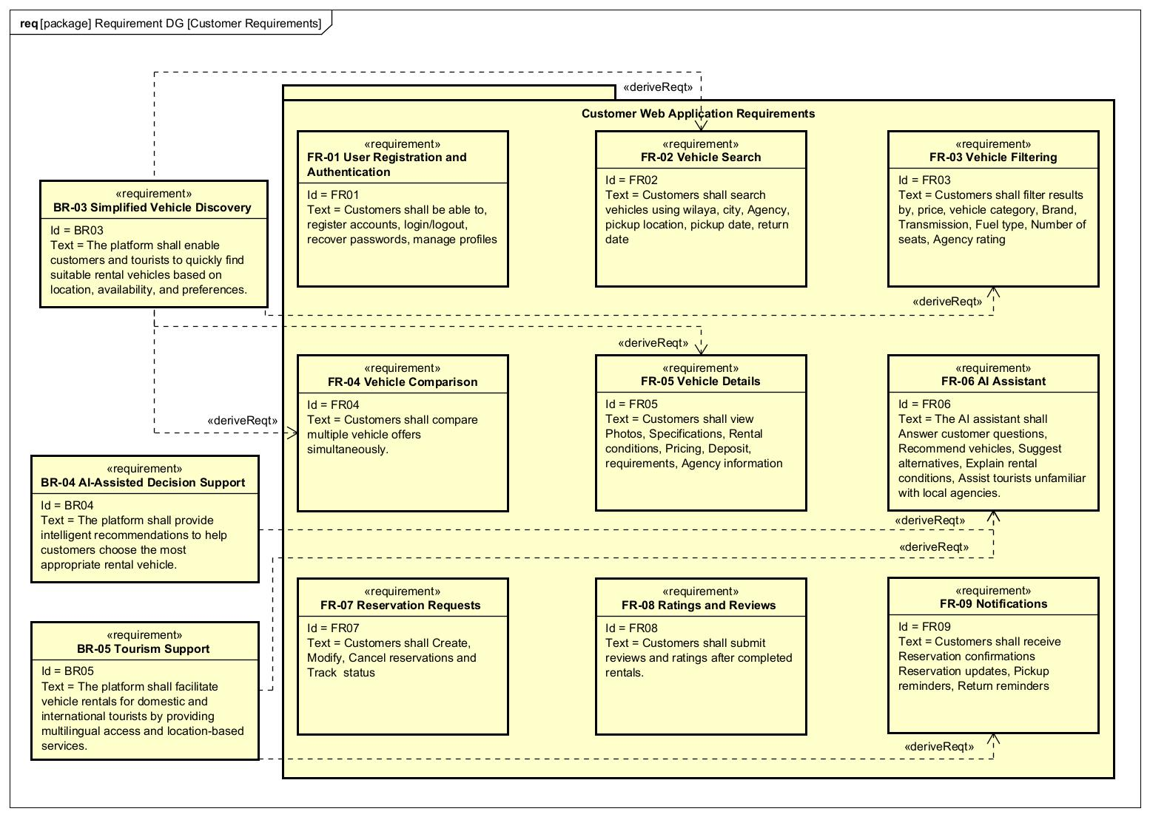
Figure 2 - Customer Requirements Diagram

Diagram 3 – Mobile Application Requirements
- FR-10 Mobile Search
- FR-11 Quick Booking
- FR-12 Location Services
- FR-13 Push Notifications
- FR-14 Offline Data Caching
Trace to:
- BR-05 Tourism Support
- BR-08 Multi-Platform Accessibility
- BR-09 Low Technical Barrier
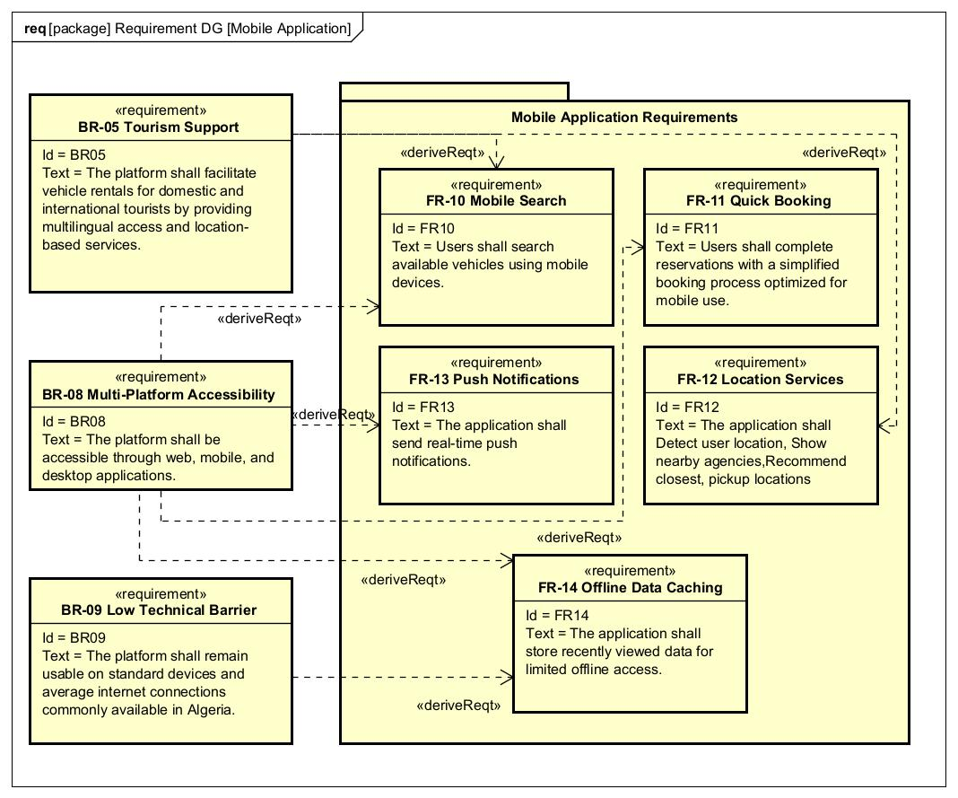
Figure 3 - Mobile Application Requirements Diagram

Diagram 4 – Agency Management Requirements
- FR-15 Agency Authentication
- FR-16 Fleet Management
- FR-17 Availability Management
- FR-18 Reservation Management
- FR-19 Pricing Management
- FR-20 Customer Management
- FR-21 Reporting Dashboard
Trace to:
- BR-02 Increased Agency Visibility
- BR-06 Digital Transformation of Agencies
- BR-10 Revenue Generation
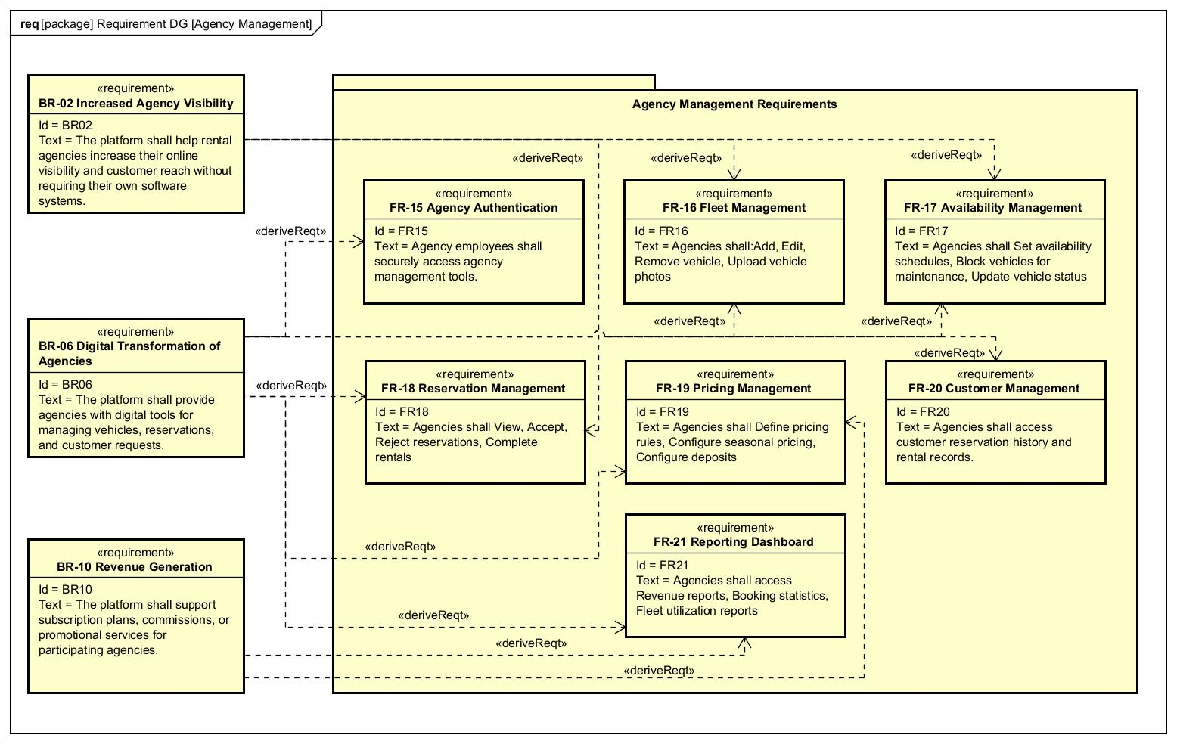
Figure 4 - Agency Management Requirements Diagram

Diagram 5 – Administration Requirements
- FR-22 Agency Verification
- FR-23 User Management
- FR-24 Content Moderation
- FR-25 System Monitoring
Trace to:
- BR-01 National Rental Agency Marketplace
- BR-07 Marketplace Neutrality
- BR-10 Revenue Generation
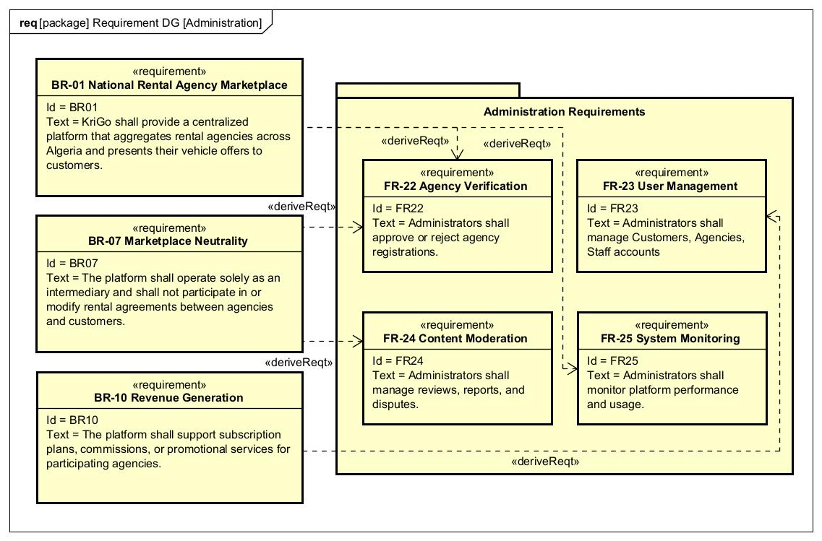
Figure 5 - Administration Requirements Diagram

Diagram 6 – Backend Services Requirements
- FR-26 Centralized API Services
- FR-27 Centralized Database
- FR-28 Recommendation Engine
- FR-29 Notification Service
- FR-30 Audit Logging
Trace to:
- BR-01 National Rental Agency Marketplace
- BR-04 AI-Assisted Decision Support
- BR-05 Tourism Support
- BR-06 Digital Transformation of Agencies
- BR-07 Marketplace Neutrality
- BR-08 Multi-Platform Accessibility

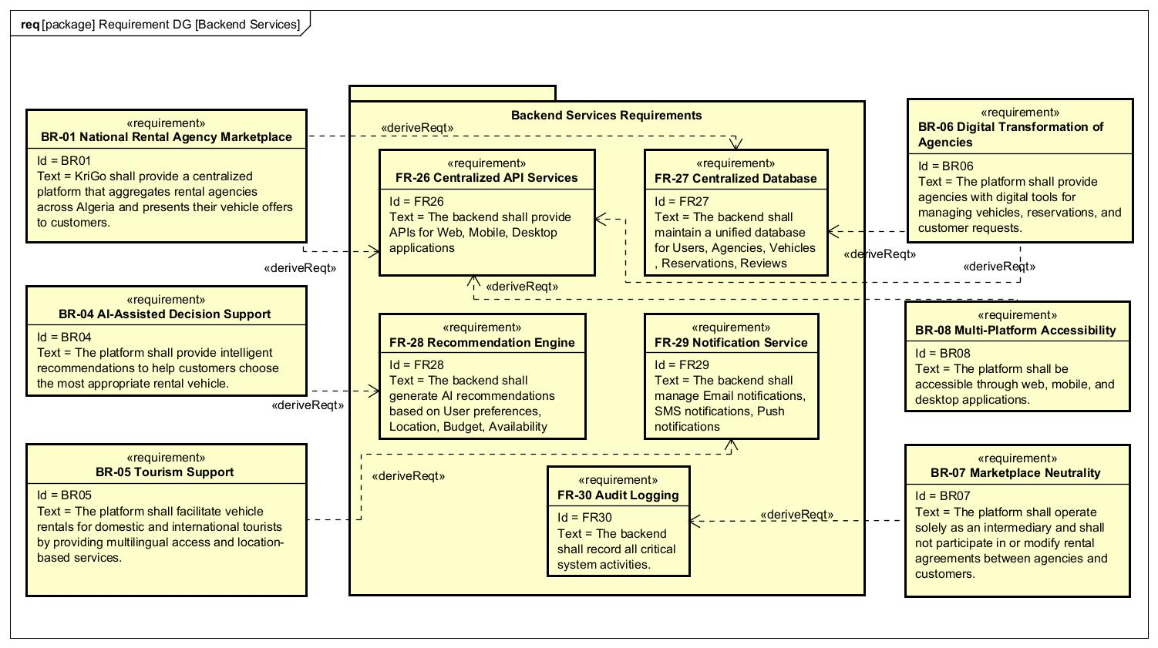
Figure 6 - Backend Services Requirements Diagram

Package 3: Non-Functional Requirements
Diagram 7 – NFR’s Performance
- NFR-01 Search ≤ 3 seconds
- NFR-02 Reservation ≤ 5 seconds
- NFR-03 5000 concurrent users
Refines:
- FR-02 Vehicle Search
- FR-07 Reservation Requests

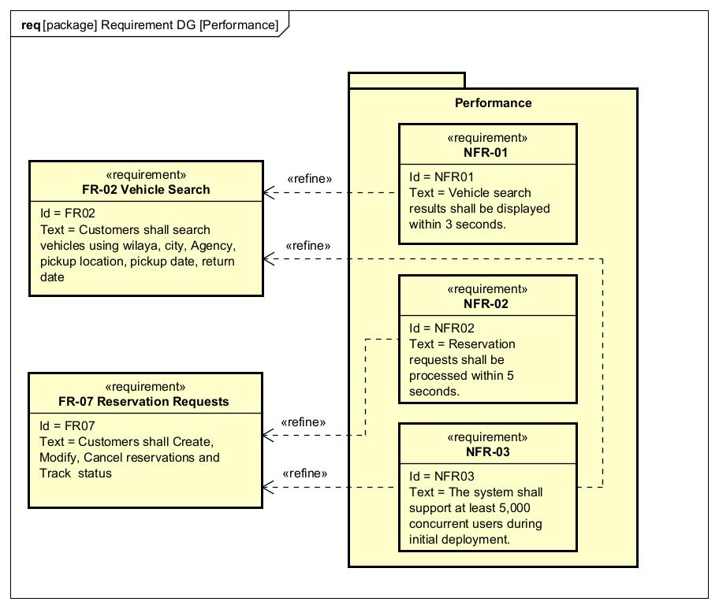
Figure 7 - Performance Non-Functional Requirements Diagram

Diagram 8 – NFR’s Security
- NFR-08 HTTPS
- NFR-09 Password Hashing
- NFR-10 RBAC
- NFR-11 Data Encryption
Refines:
- FR-01 User Registration and Authentication
- FR-15 Agency Authentication
- FR-27 Centralized Database

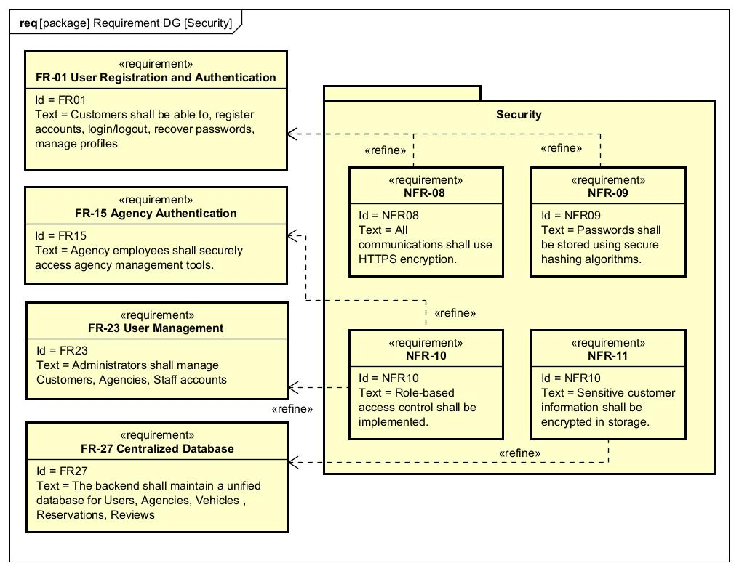
Figure 8 - Security Non-Functional Requirements Diagram

Diagram 9 – NFR’s Reliability
- NFR-21 Prevent Double Booking
- NFR-22 Transaction Consistency
- NFR-23 Data Integrity During Failures
Refines:
- FR-17 Availability Management
- FR-18 Reservation Management
- FR-27 Centralized Database

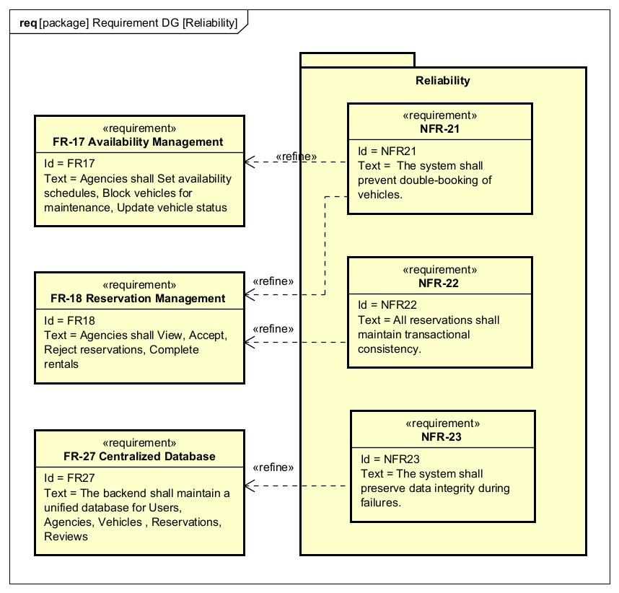
Figure 9 - Reliability Non-Functional Requirements Diagram

Diagram 10 – NFR’s Availability
- NFR-04 99.5% Uptime
- NFR-05 Automatic Recovery
Refines:
- FR-26 Centralized API Services

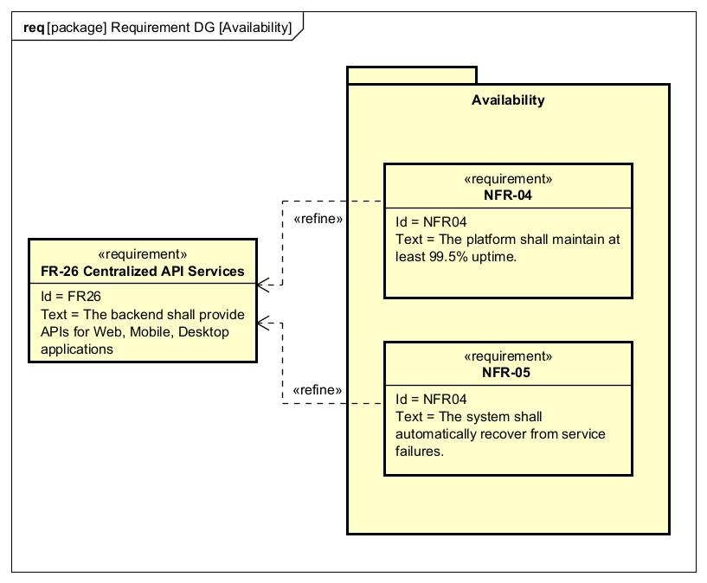
Figure 10 - Availability Non-Functional Requirements Diagram

Diagram 11 – NFR’s Scalability
- NFR-06 Add Agencies Without Redesign
- NFR-07 Horizontal Scaling
Refines:
- FR-16 Fleet Management
- FR-26 Centralized API Services
- FR-27 Centralized Database

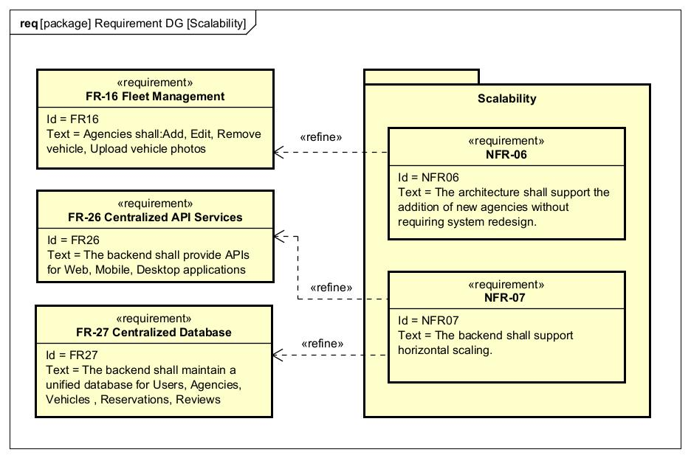
Figure 11 - Scalability Non-Functional Requirements Diagram

Diagram 12 – NFR’s Accessibility
- NFR-24 Arabic/French/English
- NFR-25 Low Bandwidth Support
- NFR-26 Standard Consumer Devices
Refines:
- FR-01 User Authentication
- FR-06 AI Assistant
- FR-10 Mobile Search
- FR-11 Quick Booking
- FR-14 Offline Data Caching
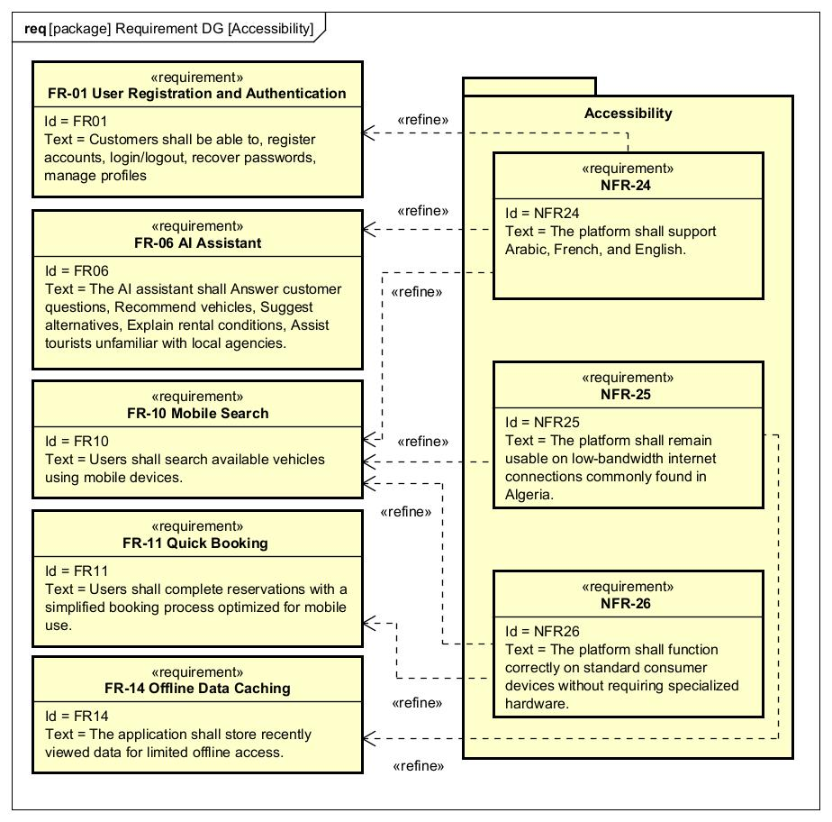
Figure 12 - Accessibility Non-Functional Requirements Diagram

Diagram 13 – NFR’s Maintainability & Compatibility
- NFR-16 Browser Support
- NFR-17 Android/iOS Support
- NFR-18 Windows Support
- NFR-19 Modular Architecture
- NFR-20 Independent Deployment
Refines:
- FR-10 Mobile Search
- FR-15 Agency Authentication
- FR-26 API Services
- FR-27 Database
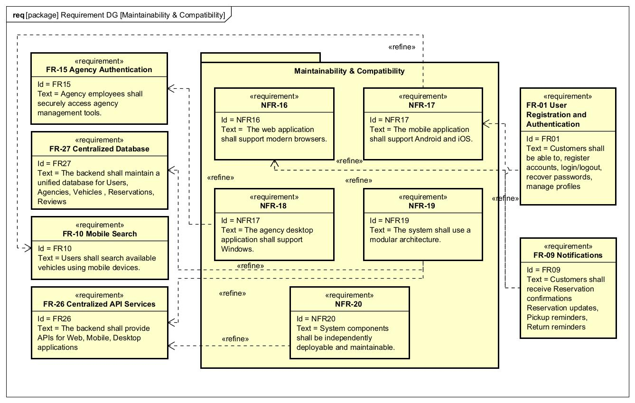
Figure 13 - Maintainability & Compatibility Non-Functional Requirements Diagram

Diagram 14 – NFR’s Usability
- NFR-12 Easy to Learn
- NFR-13 ≤ 5 Navigation Steps
- NFR-14 Accessible Design
- NFR-15 No Intrusive Ads
Refines:
- FR-01 Authentication
- FR-02 Search
- FR-07 Reservation
- FR-10 Mobile Search
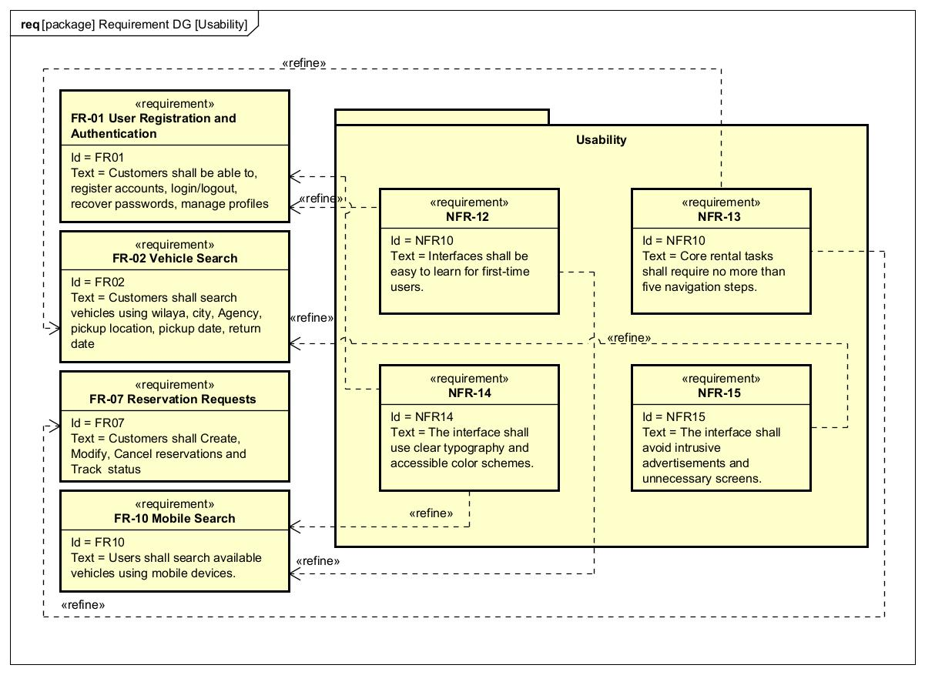
Figure 14 - Usability Non-Functional Requirements Diagram

